Java Conditional Statements — CRT Training Notes

What Are Conditional Statements?
A conditional statement allows a program to make decisions. A block of code is executed only when a specified condition evaluates to true or false.
Think of it as a real-life decision: "If it rains, carry an umbrella. Otherwise, don't."

Forms of Conditional Statements in Java
Form | Use Case
if | Single condition check
if-else | Two-branch decision
Nested if | Multiple levels of conditions
else-if ladder | Multiple mutually exclusive conditions

1. Simple if and if-else
How it works
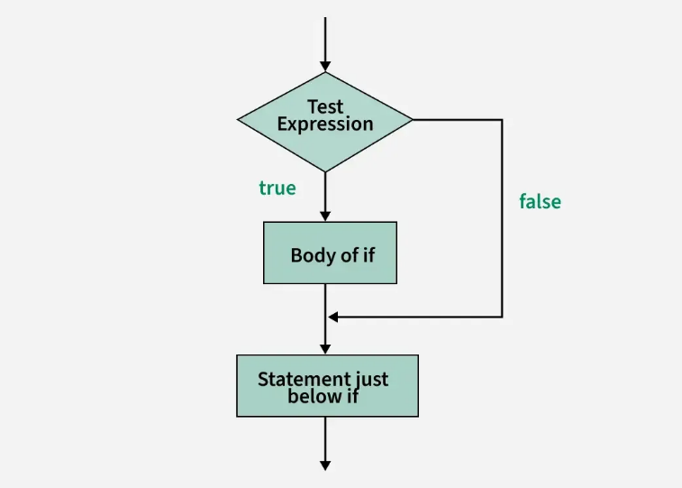
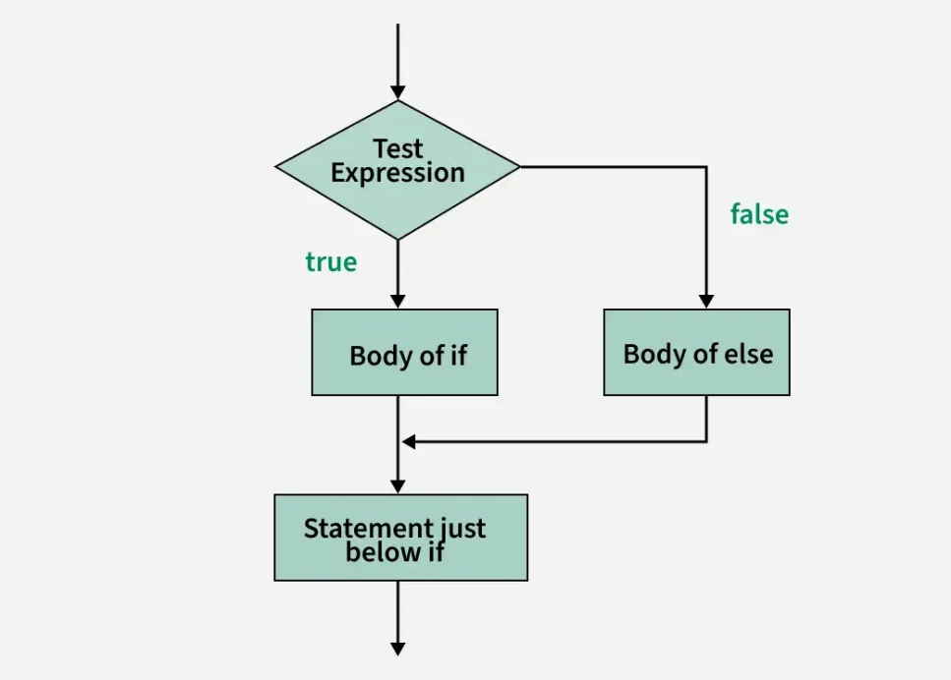
Syntax
java
if (condition) {
// executed when condition is TRUE
} else {
// executed when condition is FALSE
}
Note: The else block is optional. You can use just if without else.

✅ Practical Example — Check Positive or Negative
Step 1: Declare a variable and assign a value.
Step 2: Write the if condition using a relational operator.
Step 3: Print the result inside the appropriate block.
java
public class Test {
public static void main(String[] args) {

int x = 5; // Step 1: declare and assign

// Step 2: check the condition
if (x >= 0) {
// Step 3: executed when x is 0 or positive
System.out.println("Its Positive");
} else {
// Step 3: executed when x is negative
System.out.println("Its Negative");
}
}
}
Trace through the logic:
Value of x | Condition x >= 0 | Output
5 | true | Its Positive
-5 | false | Its Negative
0 | true | Its Positive

2. Nested if
What is Nesting?
Writing a conditional statement inside another conditional statement is called nesting. This gives us more than two branches of execution.
How it works
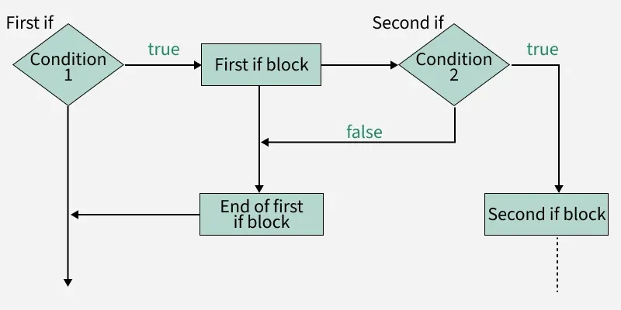

With one if-else → 2 options
With nested if-else → 4+ options

✅ Practical Example — Find the Maximum of Three Numbers
Problem: Given three numbers a, b, c, find the greatest.
Logic:
- If a > b AND a > c → a is greatest
- Else, if b > c → b is greatest
- Else → c is greatest
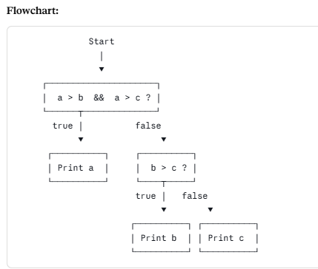

Step-by-step code:
java
public class Relational {
public static void main(String[] args) {

// Step 1: Declare three variables with values
int a = 5, b = 15, c = 10;

// Step 2: Check if 'a' is the greatest
// Both conditions must be true (AND operator)
if (a > b && a > c) {
System.out.println(a); // 'a' is greatest
}
else {
// Step 3: 'a' is not greatest — check if 'b' is greater than 'c'
if (b > c) {
System.out.println(b); // 'b' is greatest
}
else {
// Step 4: neither 'a' nor 'b' is greatest — so 'c' must be
System.out.println(c); // 'c' is greatest
}
}
}
}
Trace with a=5, b=15, c=10:
Step | Check | Result
1 | 5 > 15 && 5 > 10 | false → go to else
2 | 15 > 10 | true → print 15
Output: 15

3. else-if Ladder
What is it?
When an if block appears immediately after an else, the flower brackets can be collapsed into a cleaner, ladder-like structure. This is the else-if ladder.
Nested if form (verbose):
java
if (condition1) {
// block A
} else {
if (condition2) {
// block B
} else {
// block C
}
}
Same logic as else-if ladder (clean form):
java
if (condition1) {
// block A
} else if (condition2) {
// block B
} else {
// block C
}
Both are functionally identical. The ladder form is simply easier to read.

Ladder Structure Visualized

✅ Practical Example — Max of Three (Ladder Form)
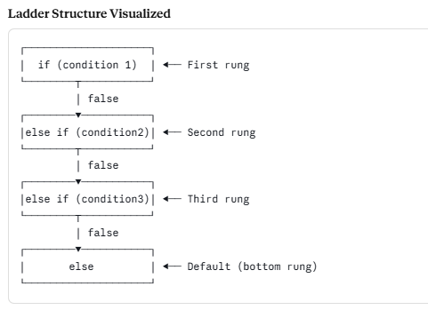
public class Relational {
public static void main(String[] args) {

// Step 1: Declare three variables
int a = 5, b = 15, c = 10;

// Step 2: Check if 'a' is greatest
if (a > b && a > c) {
System.out.println(a);
}
// Step 3: If not, check if 'b' is greatest
else if (b > c) {
System.out.println(b);
}
// Step 4: Default — 'c' must be the greatest
else {
System.out.println(c);
}
}
}
Output: 15

Quick Comparison — All Three Forms
Feature | if-else | Nested if | else-if Ladder
Branches | 2 | Multiple (complex) | Multiple (linear)
Readability | High | Low (deep nesting) | High
Use Case | Single decision | Hierarchical logic | Multiple exclusive options
Best for | Simple checks | Tree-like conditions | Grade, grade category checks

💡 Interview Spotlight
Q1. What is the difference between if-else and a nested if?
if-else provides exactly two execution paths (true or false). A nested if places a conditional statement inside another, creating multiple levels of decision-making and more than two branches. Nested if is used when the second condition only makes sense to check after the first one has been evaluated.

Q2. What is an else-if ladder? How is it different from nested if?
An else-if ladder is syntactically cleaner way of writing nested if. When the if block appears immediately inside an else block, the braces around the else can be dropped. Functionally they are identical, but the ladder reads left-to-right in a linear fashion, making it easier to maintain and debug. Interviewers sometimes call this "multi-way branching."

Q3. Can you have an if without an else? What happens if the condition is false?
Yes. else is optional in Java. If the condition is false and there is no else block, the program simply skips the if block entirely and continues with the next statement after the closing brace.

Tip for Interviews: Always mention that in an else-if ladder, only the first matching condition's block executes and the rest are skipped — even if multiple conditions could be true. This shows depth of understanding.

